

January 3rd- Board Meeting 9am
January 17th- Chili & game night 6:30pm Food provided

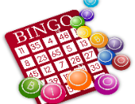
Feb. 7th-Board Meeting 9am
Feb. 14th - Annual Board Meeting 10am
Feb. 27th-Bingo Blitz and Potluck
Join us for family bingo night! 6:30pm

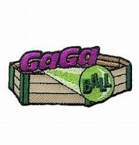
March 7th- Board Meeting 9am
March 21st – Let it Fly Gaga &
Cornhole Tournament (Overlook Park) 2pm – 4PM Friendly competition with prizes.


April 4th- Board Meeting 9am
April 4th – Easter Celebration, Egg
hunt for ages 0-12yrs and light refreshments.
Easter Basket Giveaway! 12pm
April 26th - Scavenger Hunt 2pm – 4PM


May 2nd - Board Meeting 9am
May 1 – 3rd – Community Garage Sale
May 16th – Glow night, kick off to summer!
7:30-10 pm Snacks will be served


June 6th- Board Meeting 9am
June 13th- Trash Off – time again to spruce up our neighborhood

July 4th - Board Meeting 9am. Freedom Pancake Breakfast after Meeting. Bring family & friends.


August 1st - Board Meeting 9am
August 1st - Backpack Bonanza school supply pickup. 10:30am to 12pm. St. Peters Church & TPOA Join together for the kids.


September 5th – Board Meeting 9am September 20th – Bunko & Dessert 2pm

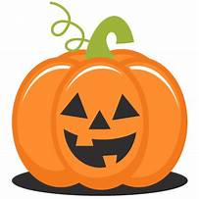
October 3rd - Board Meeting 9am
October 17th - Tamarack Family Fall Festival & Arts & Craft Fair 2pm. Join us for food, games, bounce house, pumpkin decorating, and trunk or treat!

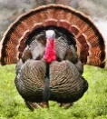

November 7th - Board Meeting 9am


December 5th - Board Meeting 9am
December 5th - Gun Barrel City Parade
December 12th- Christmas In the Park- 4:30pm. Gather to celebrate the season

